Siddharth Rane

9/13/19

Course: Physics 209

Section: ST5

Lab #1: Vibrating Strings

Standing waves occur when a crest and trough form one after the other causing certain points in a string to seem as if they stand still. In this experiment, we will see more about the properties of a string and how its behavior changes in oscillatory motion. The wavelength of a standing wave can be expressed as 2L/n, where L is the length of the string and ‘n’ is the number of antinodes occurring in an oscillating wave.  The speed of a traveling wave, v, is represented by the formula: sqrt[T/(m/L)], where ‘T’ represents the tension in the string, and ‘m/L’ represents the linear density of the string.

Procedure:

For this lab, we are given a variety of items. We are given a string, sin wave generator, wave oscillator unit, meter stick, a track and a mass hanging pan. After placing the 2x100 grams of weight on the hanging pan, we proceeded to try and find the best resonance that would give one antinode. In order to do that we had to adjust the frequency. Once we got the first antinode, we recorded a frequency of 12 hz. We calculated for wavelength and got 2. Similarly, our group did this for up till 5 antinodes and we recorded the frequency for all of them.

In experiment 2, our group had to measure the acceleration due to gravity (g). Frequency was the dependent variable, mass was our independent variable while keeping the antinodes as a constant value.

Data:

***Experiment 1***

|  |  |
| --- | --- |
| 1/n | Lambda |
| 1 | 2 |
| 0.5 | 1 |
| 0.333 | 0.667 |
| 0.25 | 0.5 |
| 0.2 | 0.4 |

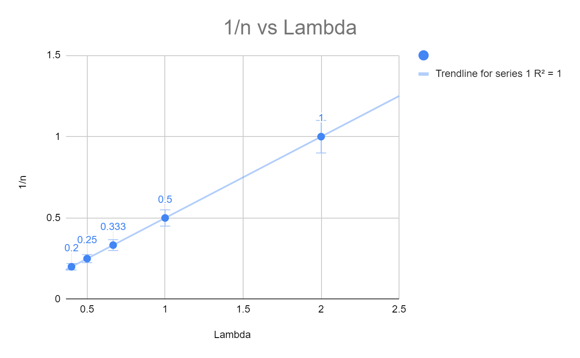

***Experiment 2***

μ = m/L ;  μ = 0.005644 kg /1 m =  **0.005644 kgm-1**

λ = **0.500 m**

n = **4 antinodes**

v = √T/μ = λf ; since T = mg, we get:

√mg/μ = λf;  mg/μ = λ2f2 → **g = (λ2f2μ)/m**

|  |  |  |  |
| --- | --- | --- | --- |
| Anti-nodes (n) | Mass (in kg) | Frequency (in hz) | g (in ms-2) |
| 4 | 0.200 | 27 | 5.143 |
| 4 | 0.100 | 22 | 6.829 |
| 4 | 0.050 | 19.2 | 10.403 |
| 4 | 0.025 | 17.4 | 17.088 |

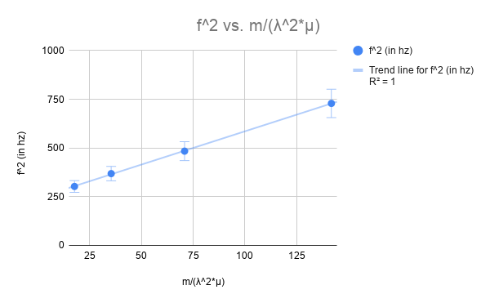

{(9.87 - 9.81) / 9.81} * 100 = **0.61% error**

Questions:

What aspects of the experiment would you refine to make a better measurement?

The more weight on the hanging pan meant an increase in tension. However, too much tension would snap the string, so we had to make sure the weight wasn’t too heavy. Humans are also likely to create errors, so we had to use our best judgement for finding the resonance.

Conclusion:

In this experiment, we were able to see the properties of how a string oscillates when transverse waves were generated. I was also able to see the relation between wavelength and the number of antinodes of the standing wave. They are inversely proportional to each other and as the number of antinodes decrease, lambda increases. The elasticity of the string made it difficult to measure the length of the string. If the string was pulled on both ends, the string would extend out and an inaccurate measurement would be taken of the string’s length. The lab allowed our group to gain a more constructive understanding of the properties of a string and how it reacts when it undergoes oscillation.